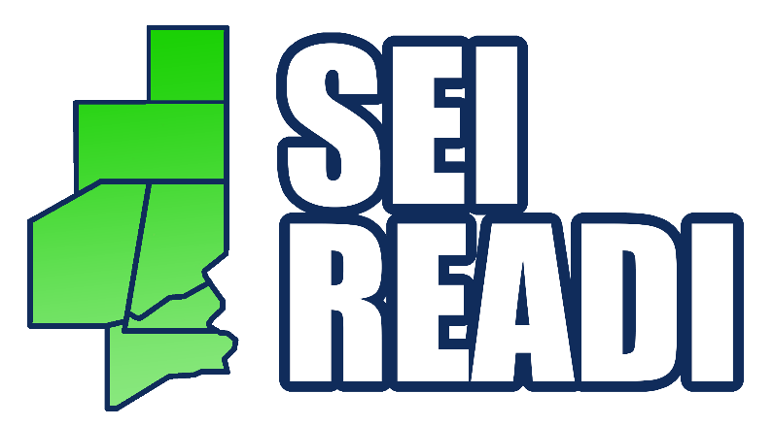

The region’s proposal for READI 2.0 centers around five overarching pillars and related goals for local, regional, and state investment in the six-county region:
● Housing and Neighborhoods – Provide 1,800 new housing units by 2030 and ensure that those new assets are available at attainable price points based on annual per capita income earnings.
● Culture, Tourism, Recreation, and Lifestyle – Preserve, enhance and activate our communities, destinations and recreational activities as a front-line resource to grow our regional population by 5,000 residents by 2030.
● Infrastructure – Increase regional infrastructure capacity and reach by 10% to ensure that our regional transportation and utility infrastructure systems are safe, efficient and meet the needs of our current and future residents and businesses.
● Business Retention, Growth, and Attraction – Grow our regional target industries by adding 2,500 jobs by 2030 through business recruitment, expansion, and attraction efforts in an effort to increase the per capita income by 2.50% per year.
● Child Care – Expand access to quality and affordable child care and early education programs by 10% percent each year through 2030.

